For bot update just change the class names mam as facebook changes it every now and then for

1. Total friends

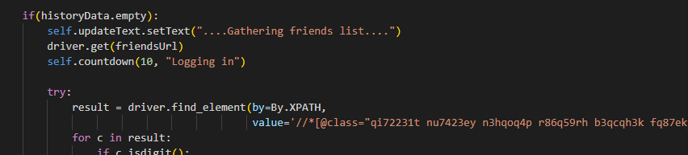

Change the class name via

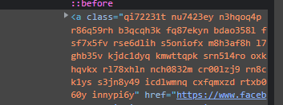

Via

 < - this button

And then clicking on “4,9 Mill Amigos”

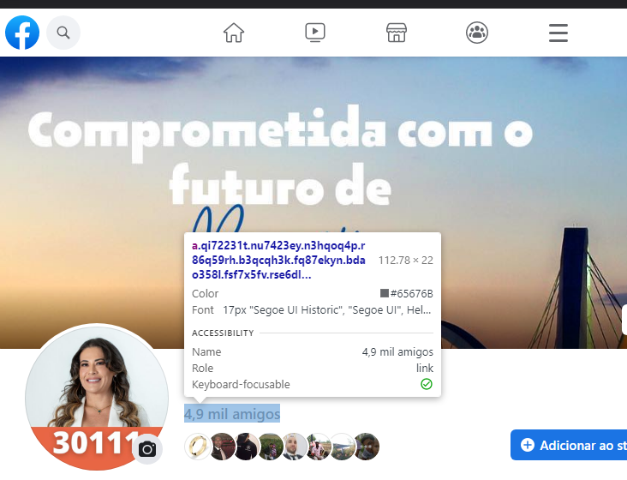

1. Friends Names

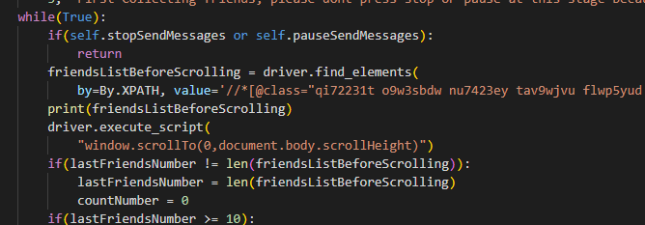

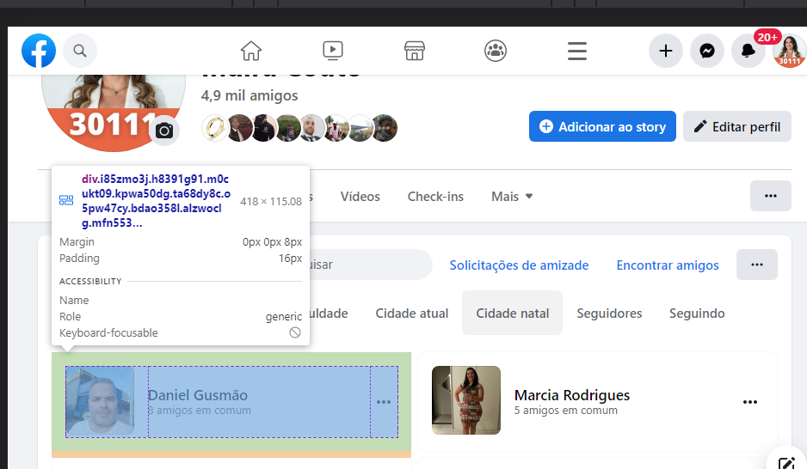

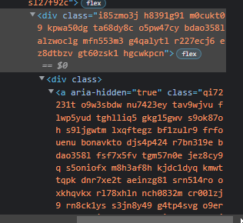 <- Copy the red highlighted class and replace it with already present in the code

